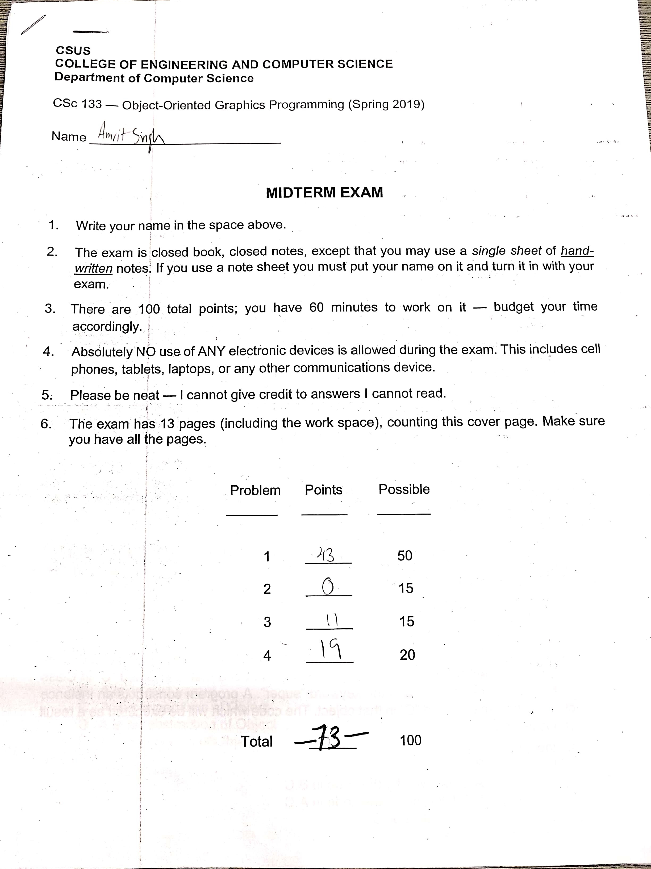

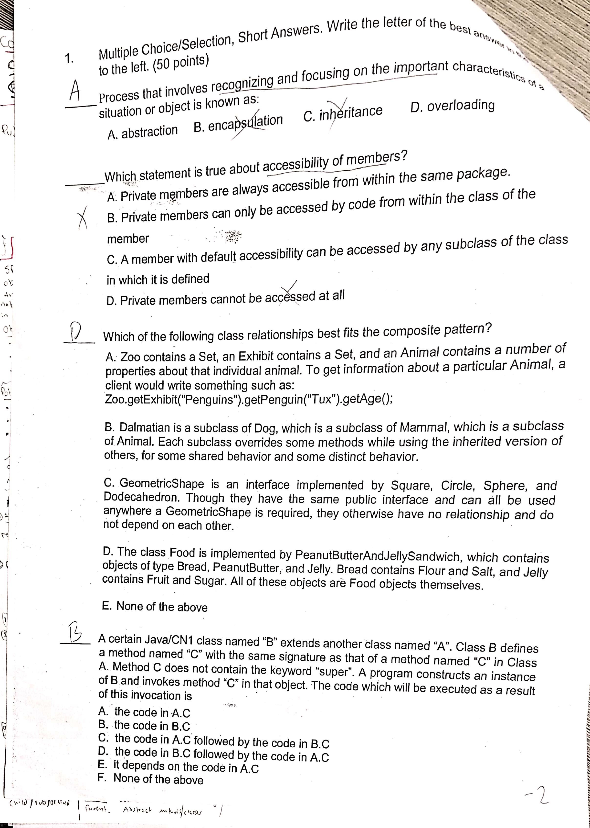

__B__ Which Statement is true about accessibility of members?

Private members can only be accessed by code from within the same package. Private methods are helpful because they can only be used within the scope they are introduced within.

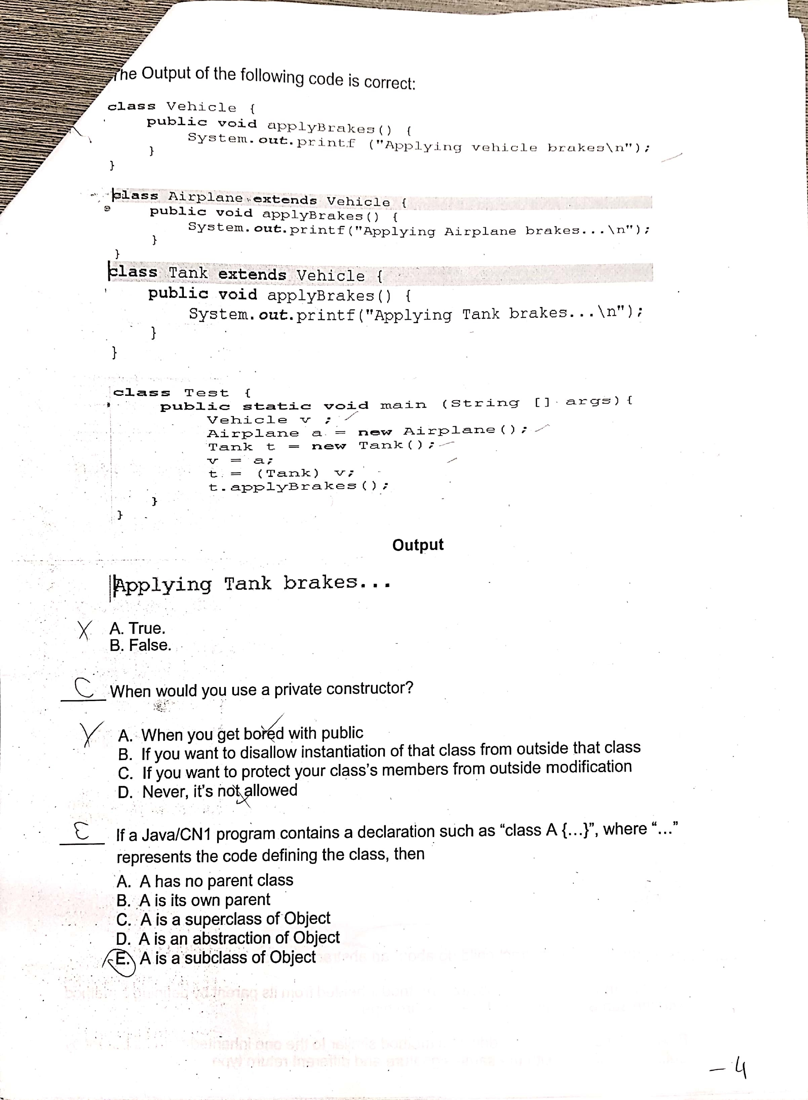

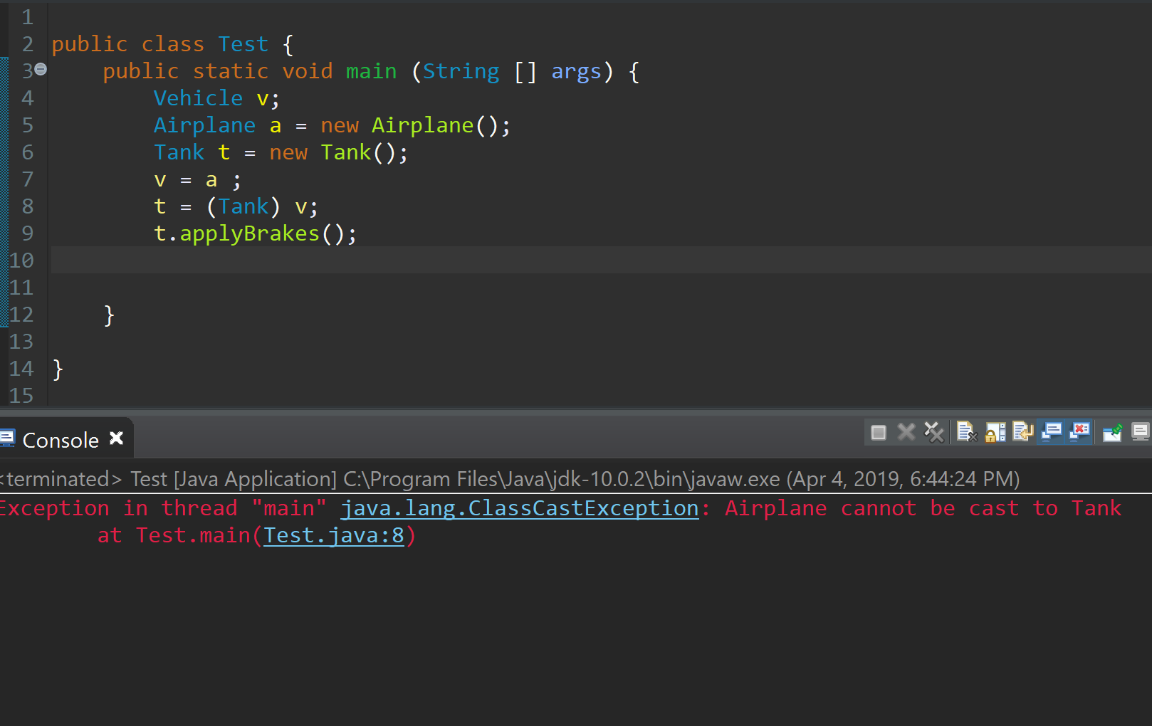

__A__ The Output of the following code is correct: FALSE

Airplane cannot be cast to Tank.

_B__ When would you use a private constructor

You would use a private constructor when you want to disallow instantiation of that class from outside that class.  Privateconstructors are used when you want to prevent and instance of a class when there are no instance fields or methods.

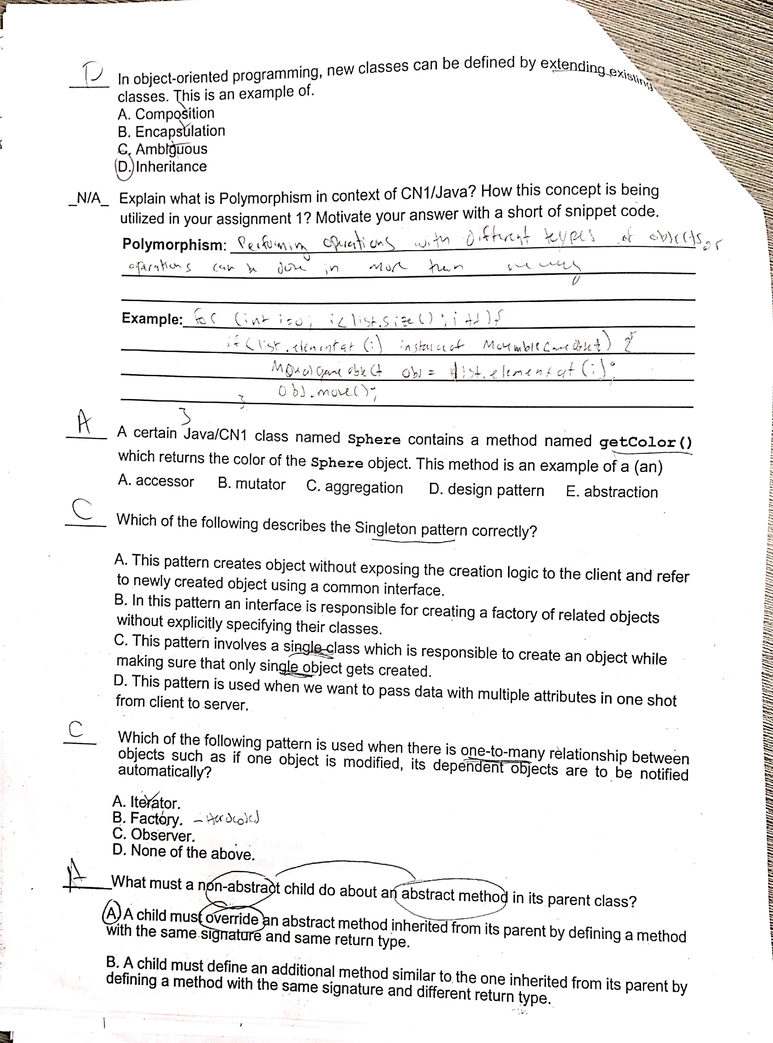

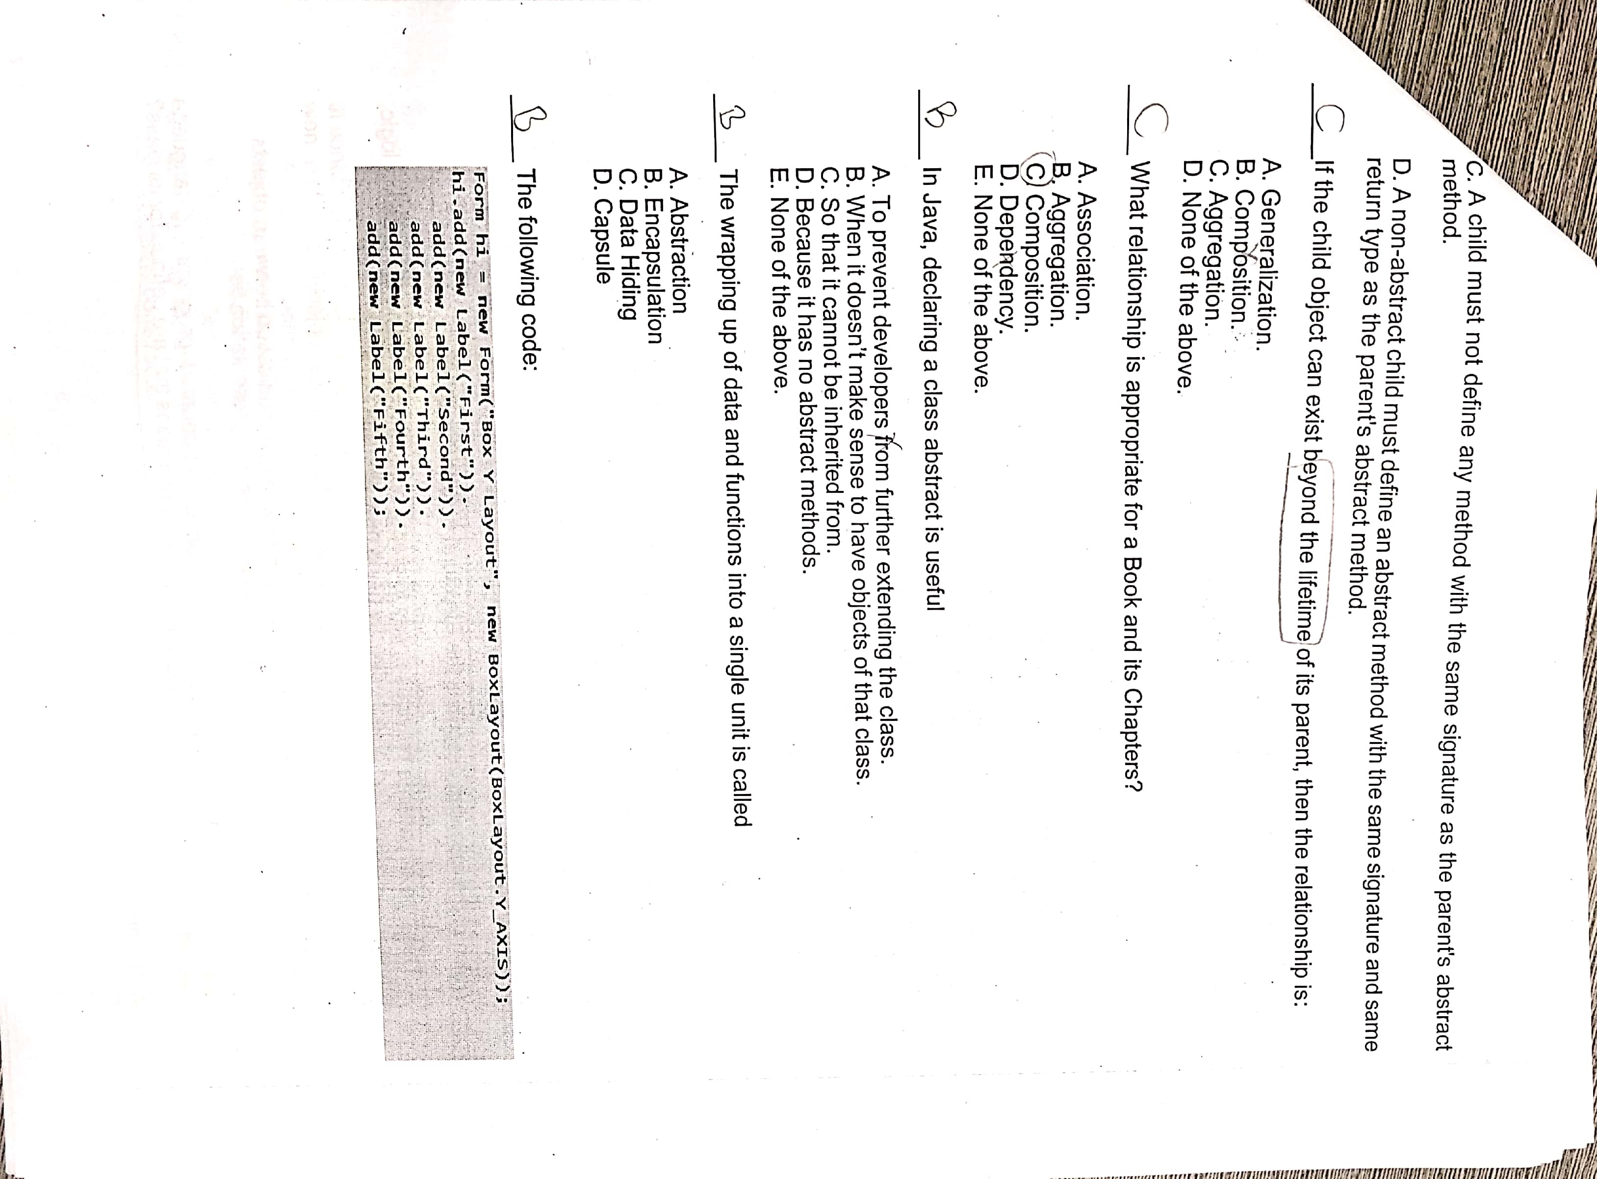

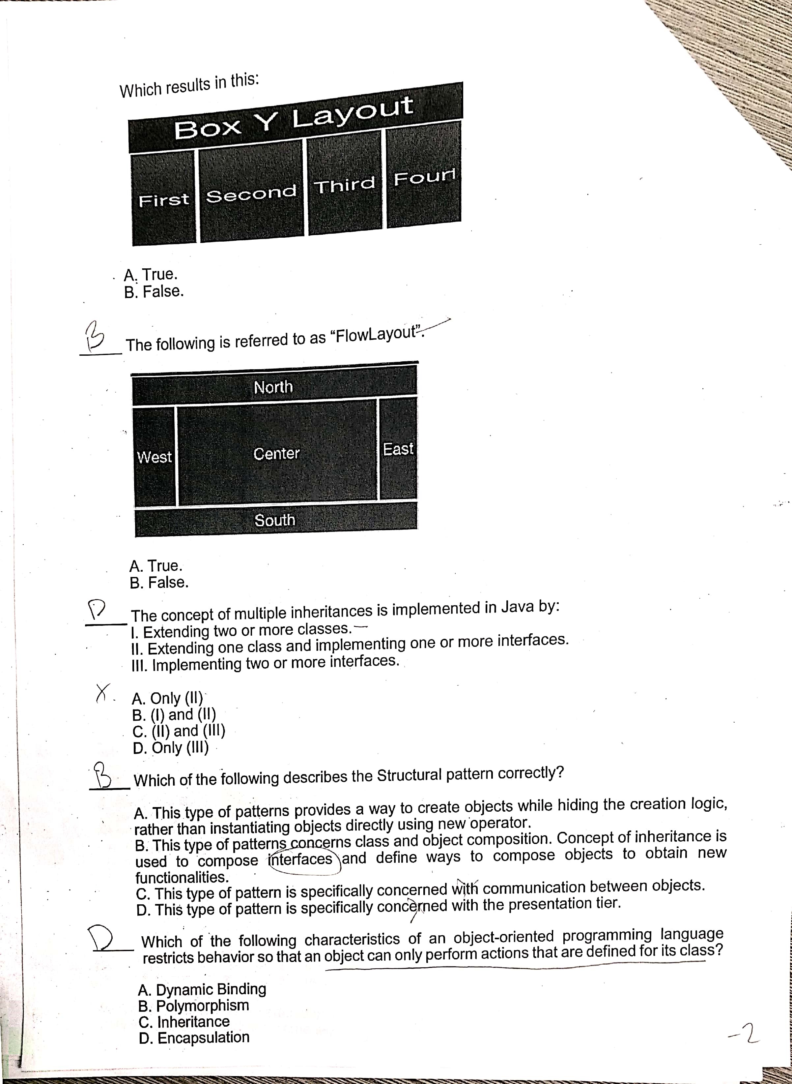

__C__ The concept of multiple inheritance is implemented in Java by

Extending one class and implementing one or more interfaces. And also by Implementing two or more interfaces.

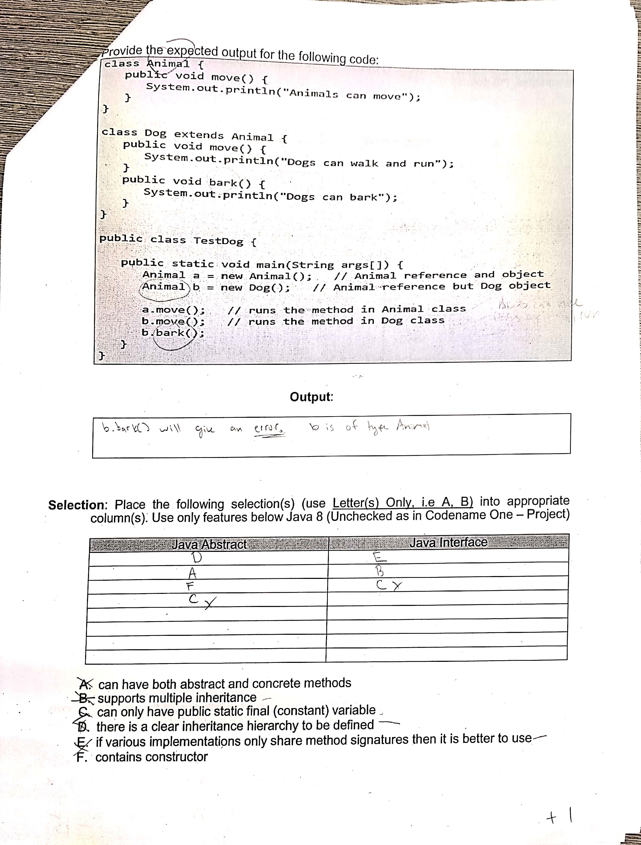

|  |  |
| --- | --- |
| JAVA ABSTRACT | JAVA INTERFACE |
| A | C |
| D | B |
| F | E |

My only mistake in this problem was thinking that both interfaces and abstract classes could have public static final (constant) variables. I now know that only interfaces can have public static final (constant) variables.

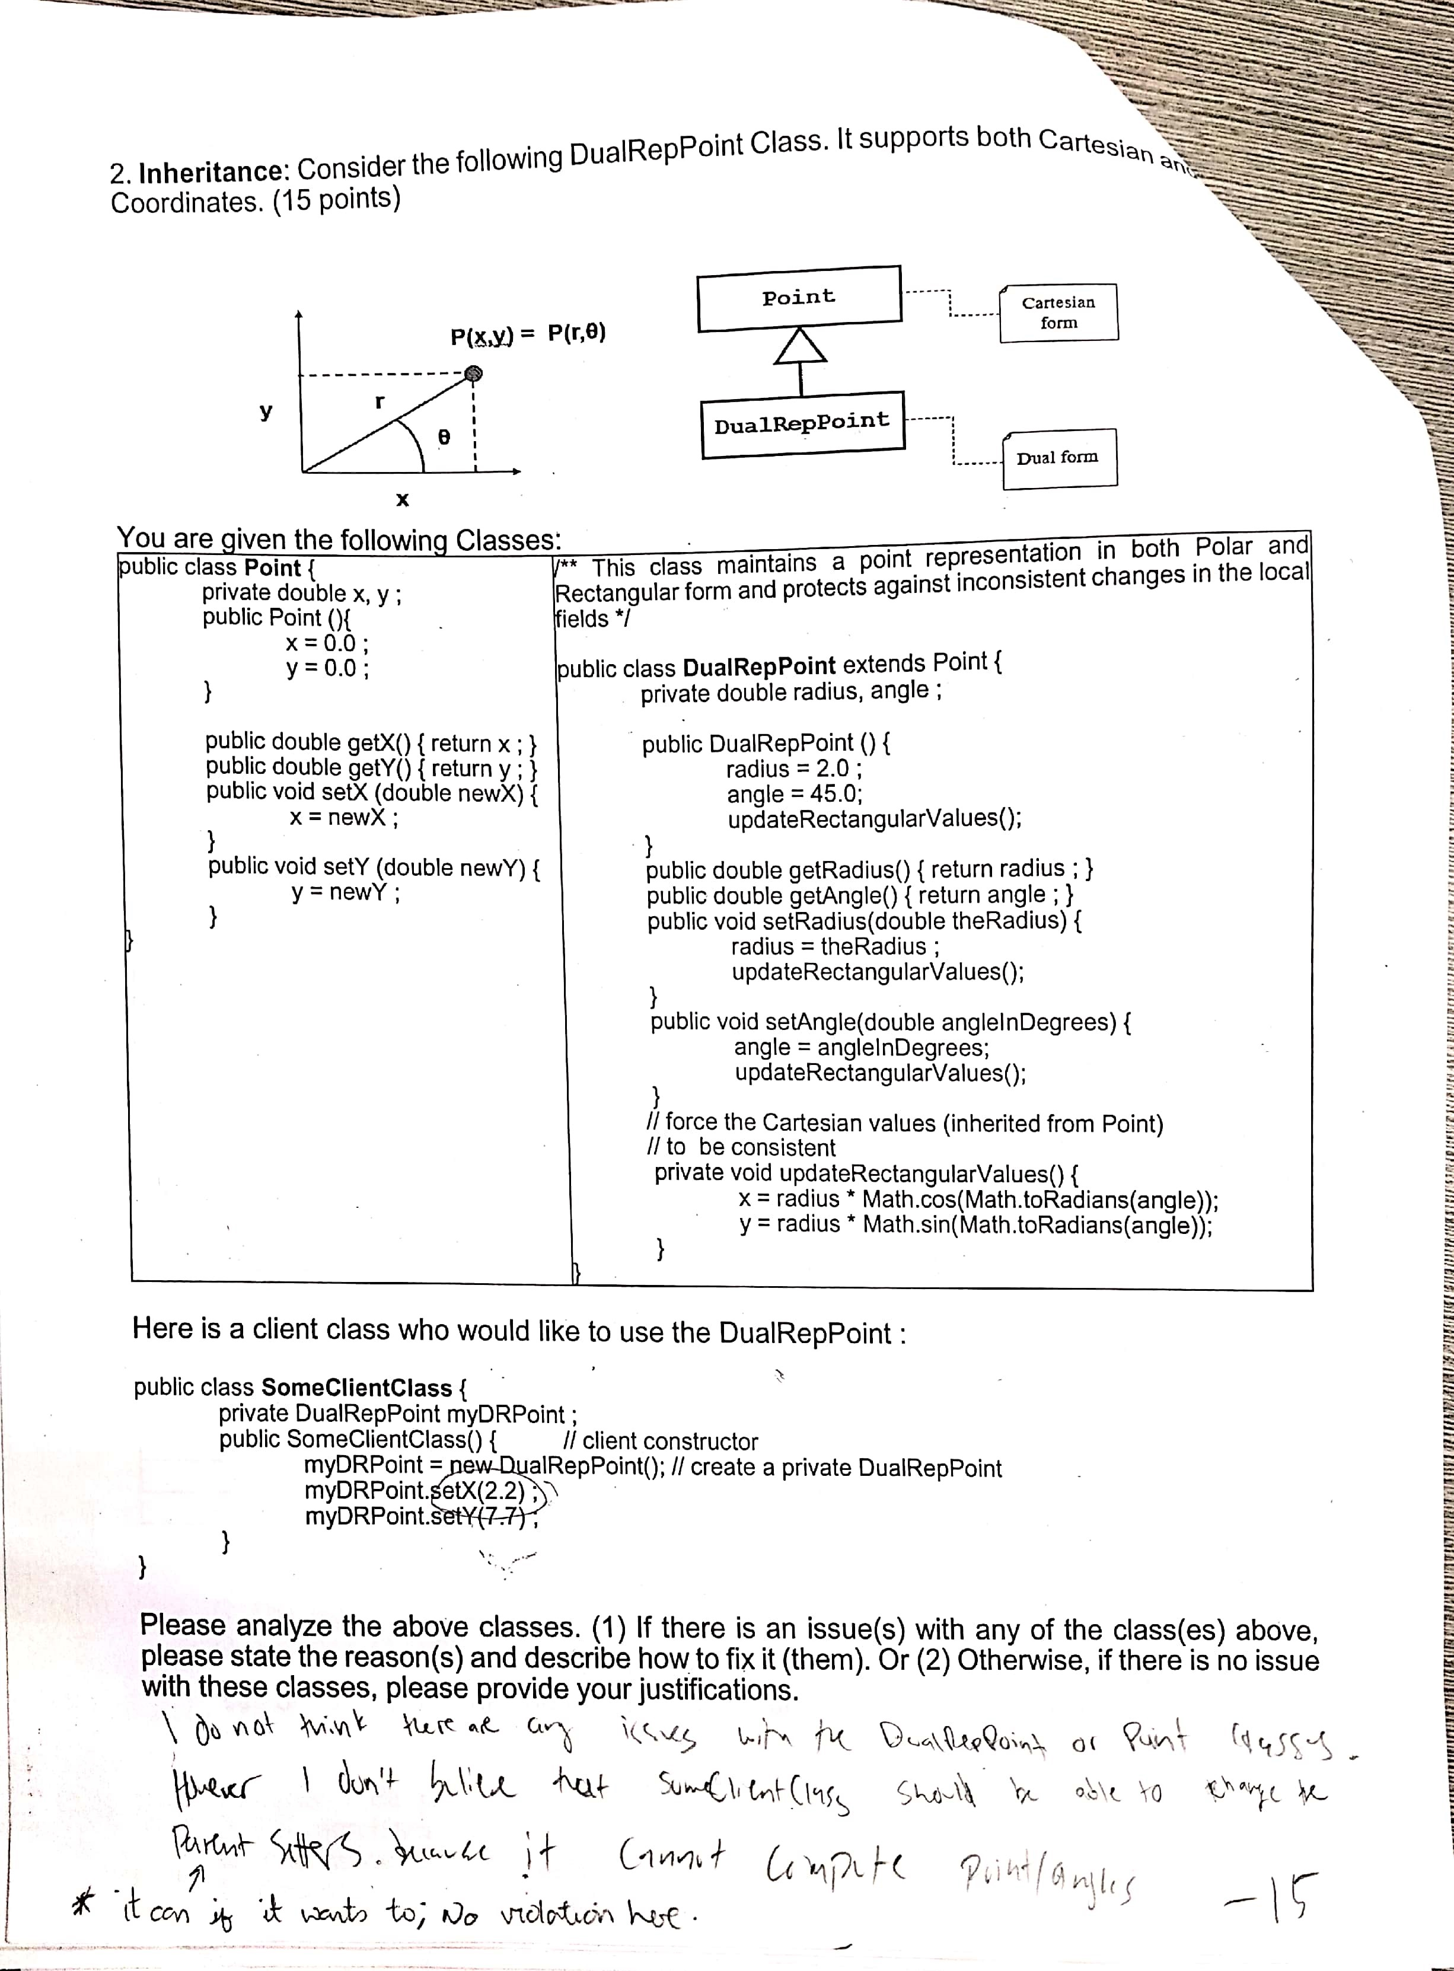

The updateRectangularValues cannot directly modify/access the x and y values. It needs to use mutator methods in order to modify them. This can be fixed by using setX() and setY(). There is nothing is wrong with the Point class. This is because it has private variables and has accessors and mutators to represent cartesian form. That being said, the client class should not be able to mess with parent’s setters because it does not compute both the points and the angle

